**Problem 1**: /* Problem 1: Display last_name, first_name, and job_id and the following calculated column from the employees table:

Multiply the salary by 18.273% which represents the default federal and state withholding. Round the result to two decimal places and name this calculated column Fed_State_Witholding. Filter by job_id values of FI_ACCOUNT and IT_PROG. Order the resulting data set by job_id and last_name in ascending order.

*/

SELECT last_name, first_name, job_id, ROUND(salary*0.18273, 2) AS "Fed_State_Witholding"

FROM employees

WHERE job_id IN('FI_ACCOUNT','IT_PROG')

ORDER BY job_id, last_name

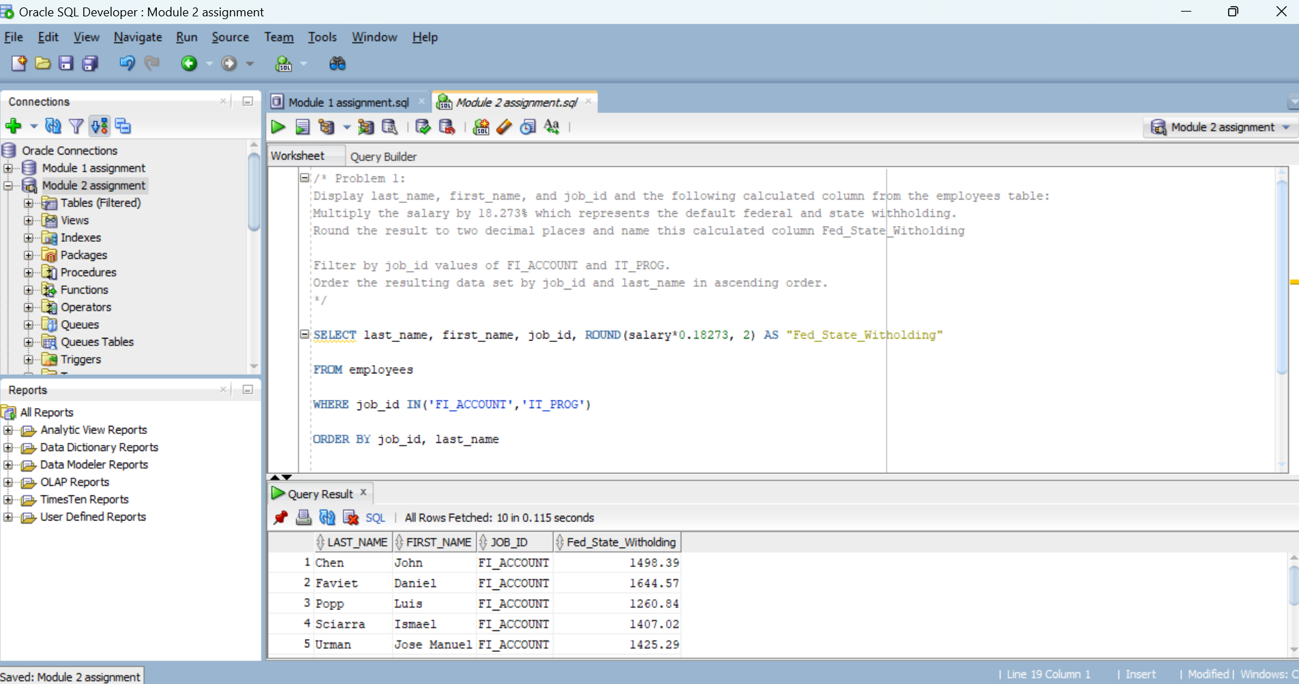

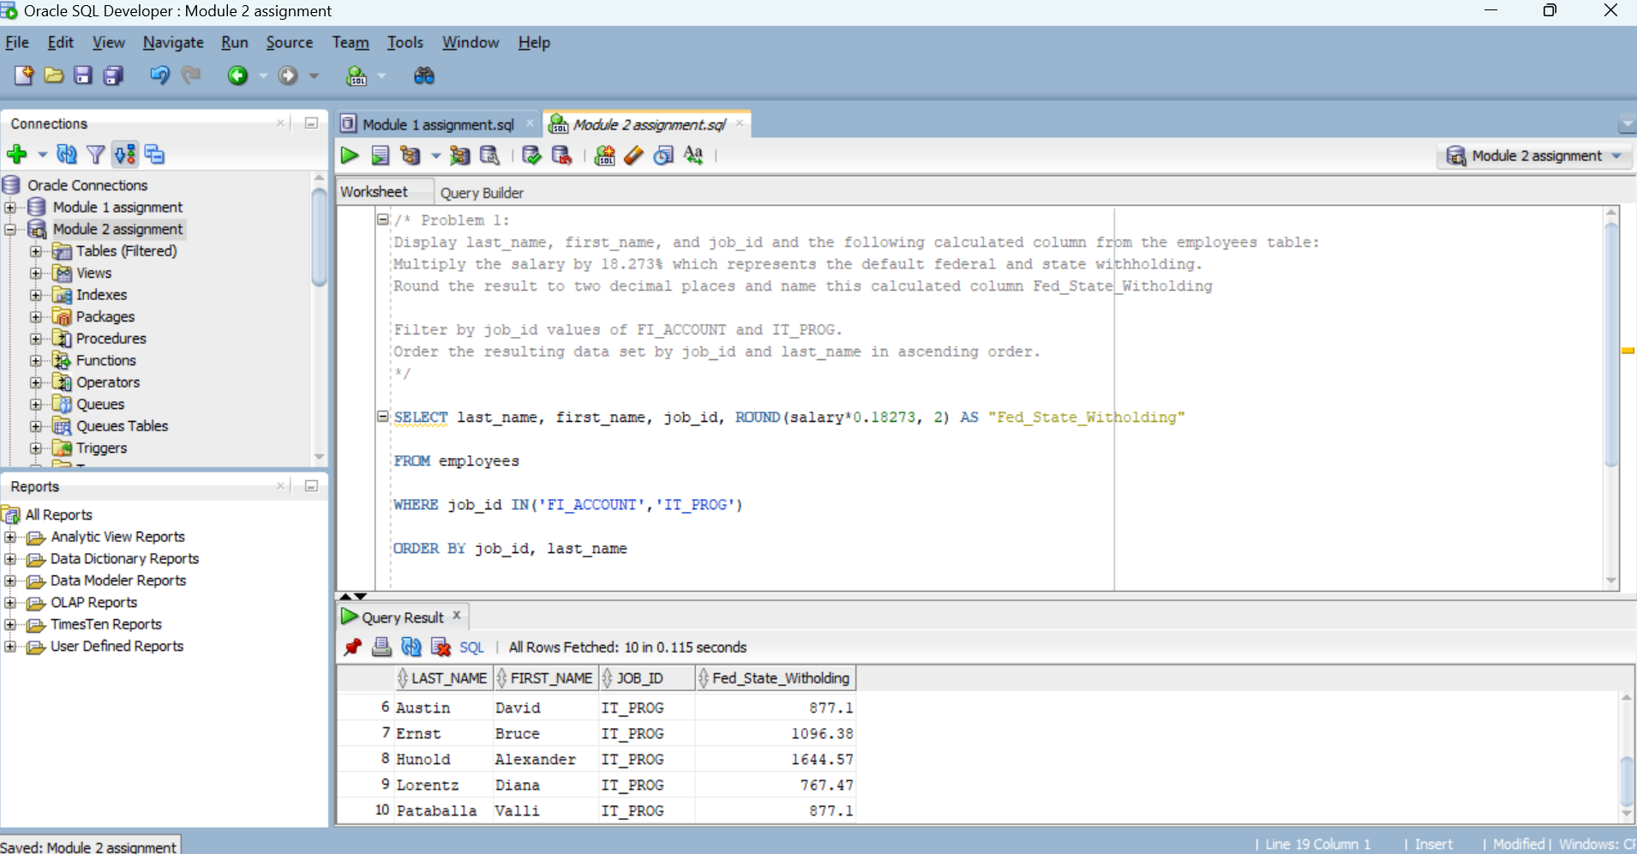

/\***Problem 2**:

Display the minimum, median, and maximum pay_raise value from the salary_raise table for an eff_date value of July 1, 2006

*/

SELECT MIN(pay_raise), MEDIAN(pay_raise), MAX(pay_raise)

FROM salary_raise

WHERE eff_date = '01-jul-2006'

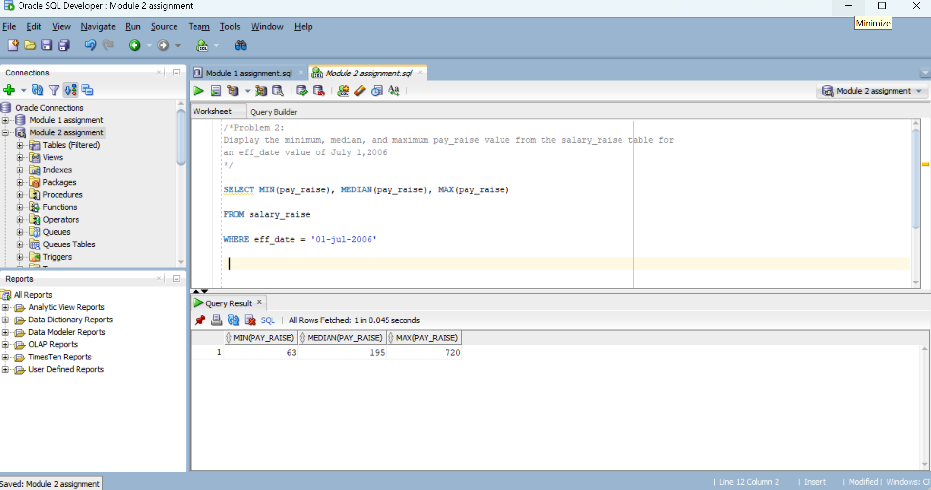

**/*Problem 3**:

Display location_id, city, state_province and the following derived column from the locations table:

Display the state_province column, in case the state_province value is null display the city column again. Alias this column State_Province_City. Order the resulting data set by country_id and city in ascending order.

*/

SELECT country_id, location_id, city, state_province, NVL(state_province, city) AS "State_Province_City"

FROM locations

ORDER BY country_id, city

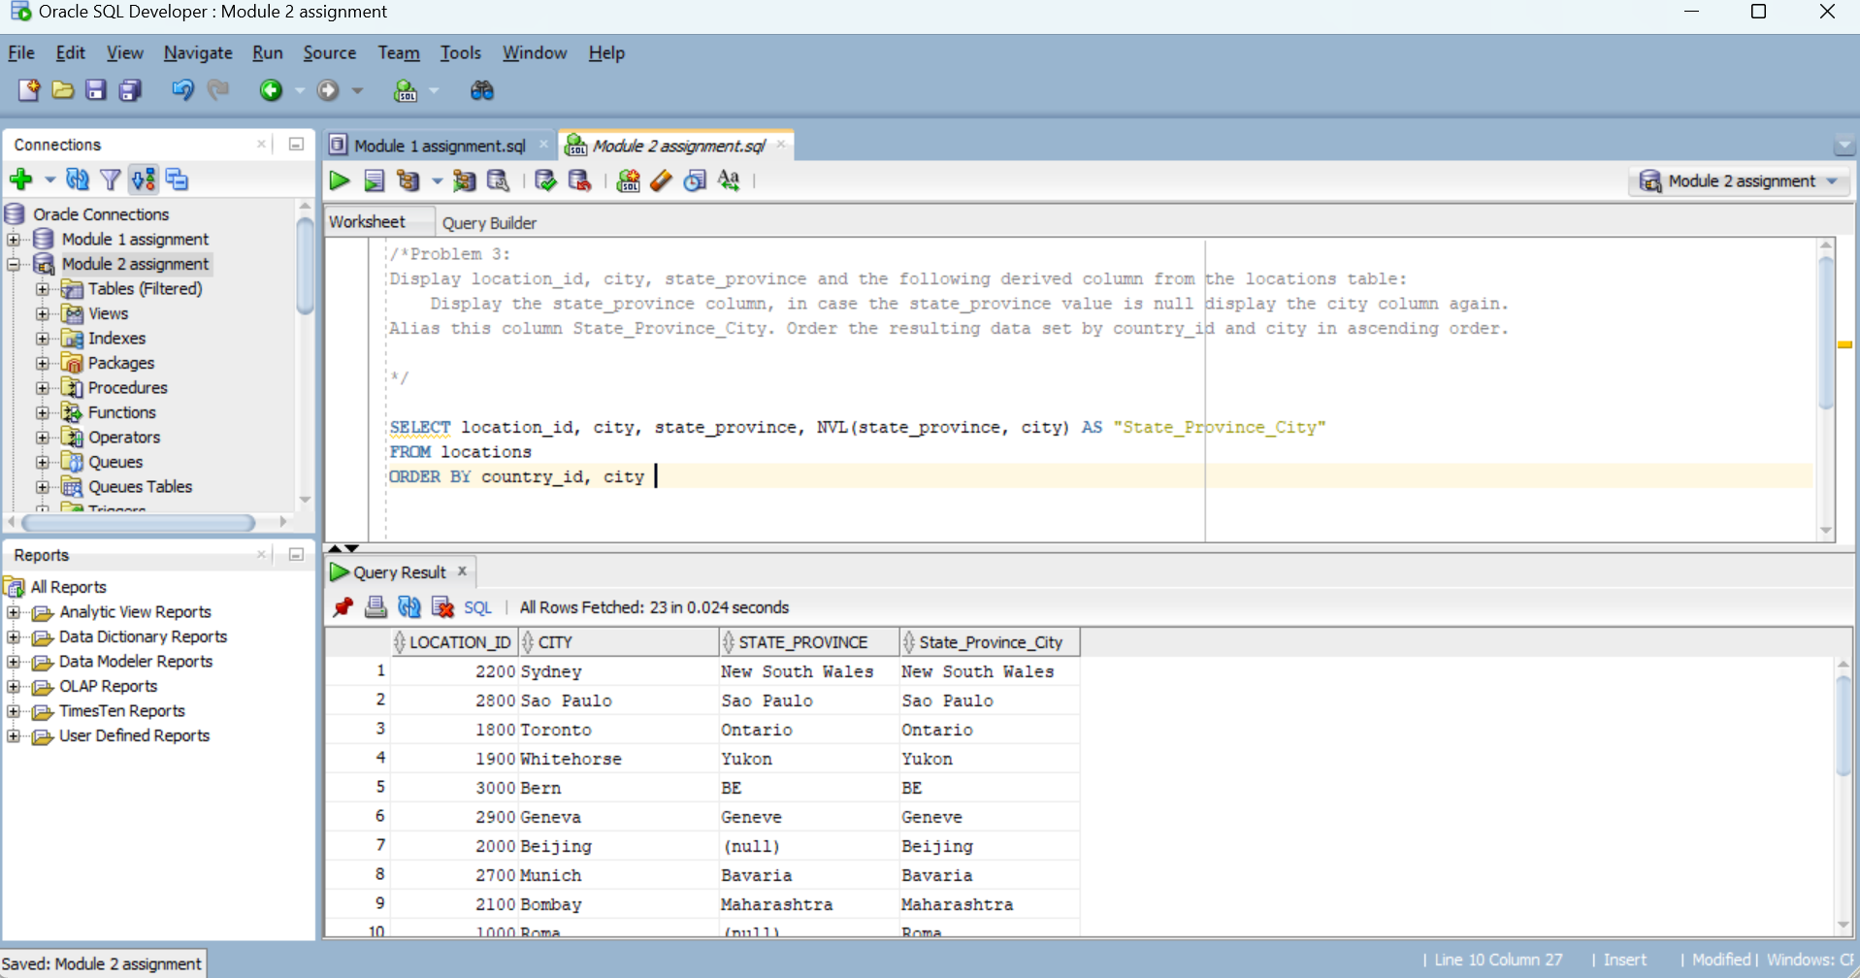

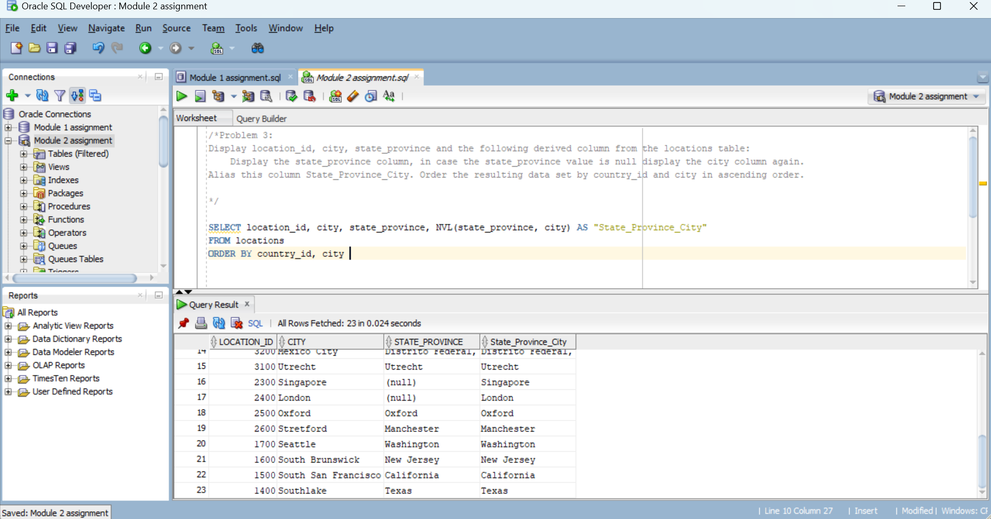

**/*Problem 4**:  
Display last_name, hire_date, department_id and the following derived columns from the emplyees table:  
 Round the hire_date by month (still display the entire date) and alias this column round_hire_date  
 Truncate the hire_date by month (still display the entire date) and alias this column trunc_hire_date  
Filter by department_id 60 and sort it by last_name.  
Based on the output, explain why for some hire_date values the rounded and truncated dates are the same and for  
other hire_date values they are different.

*/

SELECT last_name, hire_date, department_id, To_CHAR(ROUND(To_DATE(hire_date), 'Month'), 'Month dd/yyyy') AS "round_hire_date"

FROM employees

WHERE department_id = 60

ORDER BY last_name

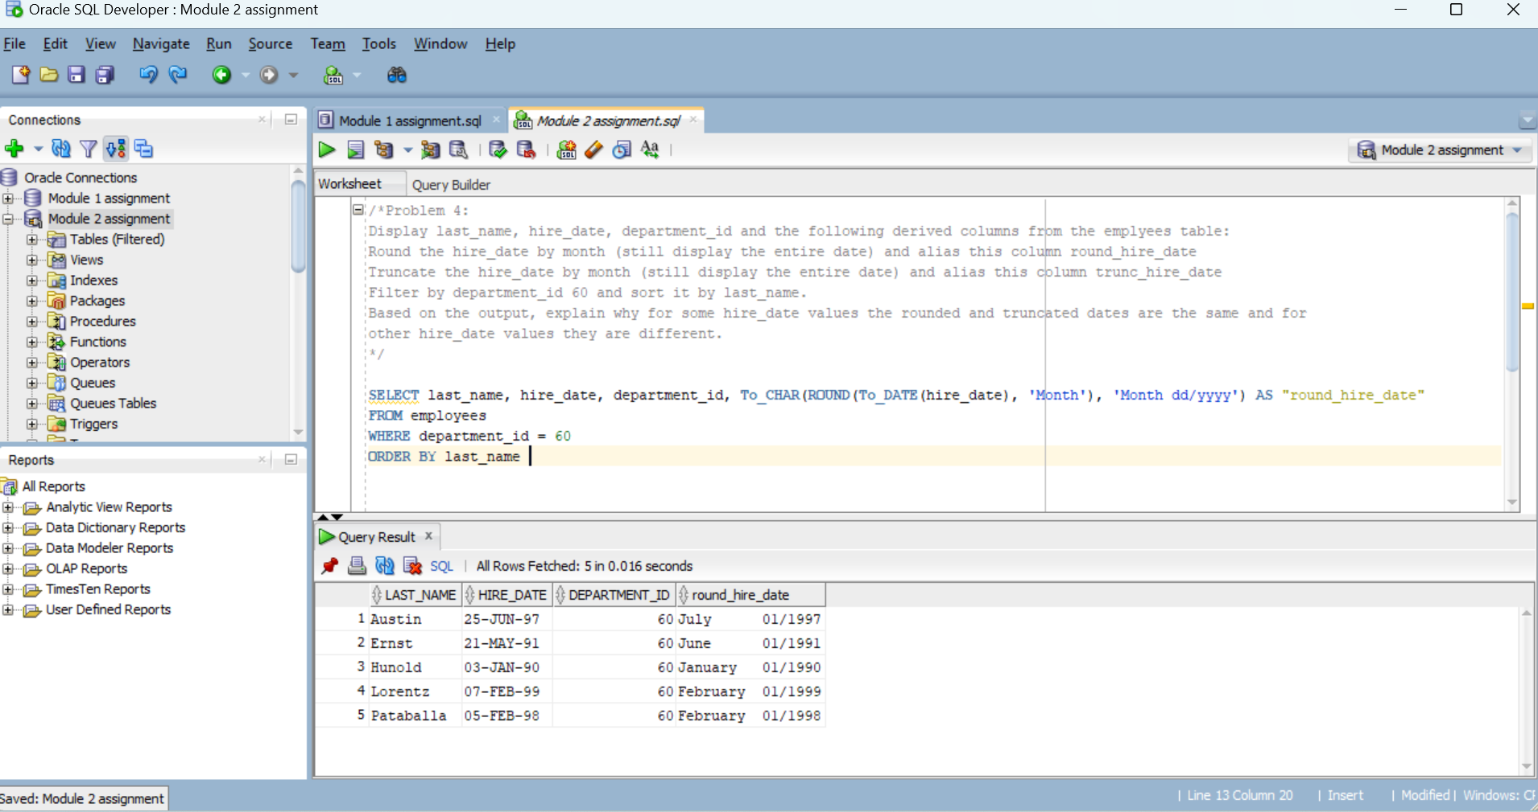

SELECT last_name, hire_date, department_id, To_CHAR(TRUNC(To_DATE(hire_date), 'Month'), 'Month dd/yyyy hh24:mi:ss') AS "trunc_hire_date"

FROM employees

WHERE department_id = 60

ORDER BY last_name

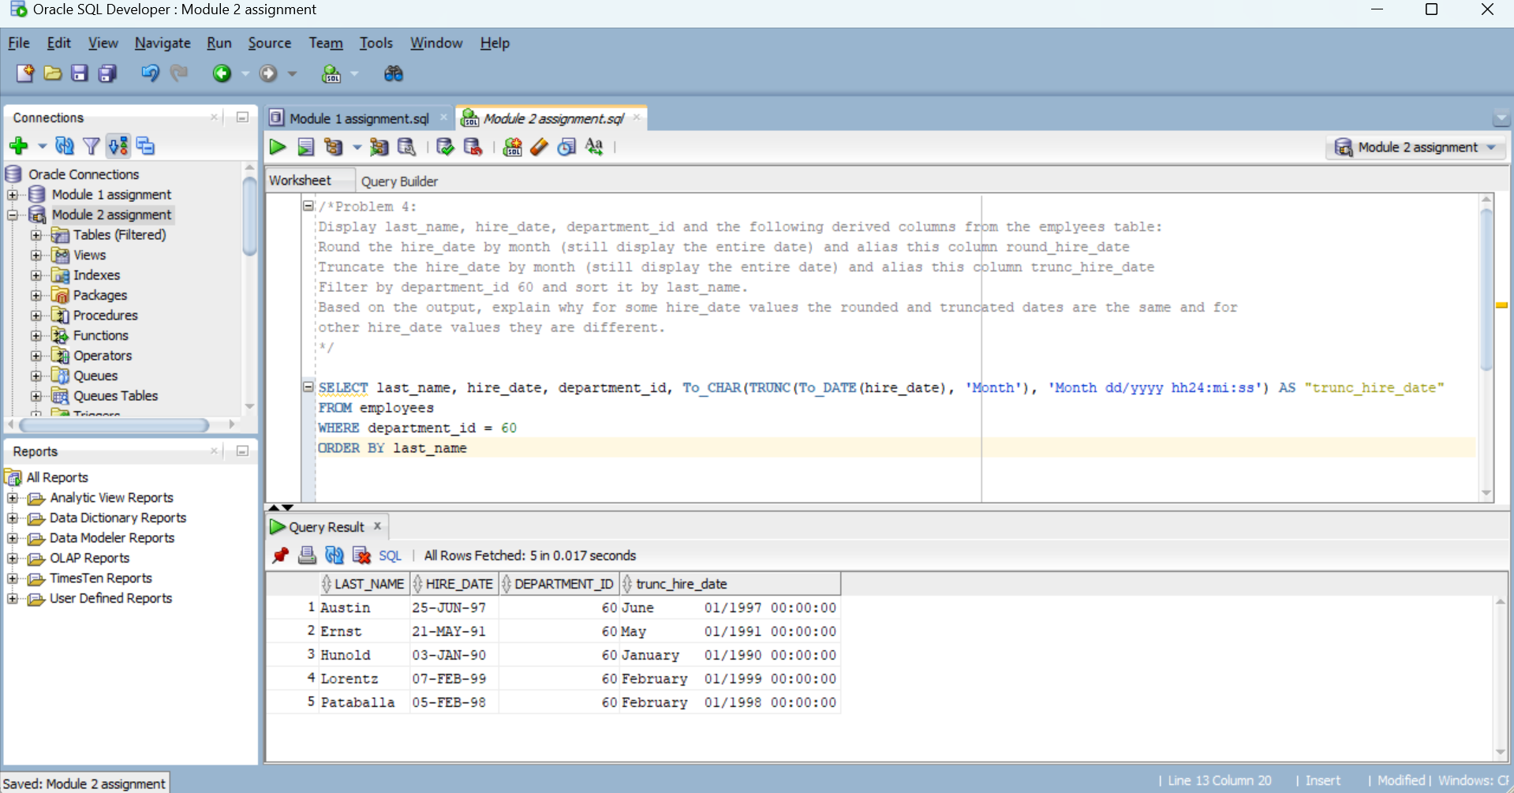

Explanation:

Since we are rounding date by month, the month of the date with the day before 15 would be the same month and the month of the date with the day after 15 would be the changed to next month. On the other hand, when we are truncating date by month, the month would be the same no matter what the day is.

As a result, 25-JUN-97 and 21-MAY-91 would be July 01/1997 and June 01/1991 after rounded by month and June 01/1997 00:00:00 and May 01/1991 00:00:00 after truncated by month. (hire_date values are the different)

03-JAN-90, 07-FEB-99 and 05-FEB-98 would be January 01/1990, February 01/1999 and February 01/1998 after rounded by month and January 01/1990 00:00:00, February 01/1999 00:00:00 and February 01/1998 00:00:00 after truncated by month. (hire_date values are the same)

/* **Problem 5**:

Display hire_date, job_id and the following derived column based on first and last name from the employees table:  
 Concatenate the last_name, a comma and blank space, and the first name together and alias this columnfull_name. Convert the last name to upper case and the first name to init case.  
Limit the output by employees having a job_id starting with ST (= STOCK).

Sort the resulting data set in descending order by hire_date.

*/

SELECT hire_date, job_id, Upper(last_name) || ', ' || Initcap(first_name) AS "full name"

From employees

WHERE Substr(job_id,1,2)= 'ST'

ORDER BY hire_date DESC;

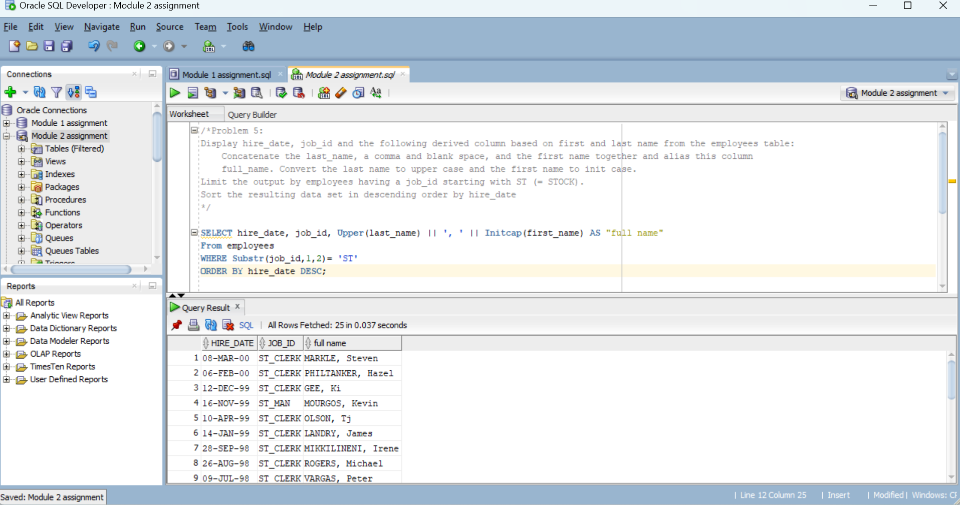

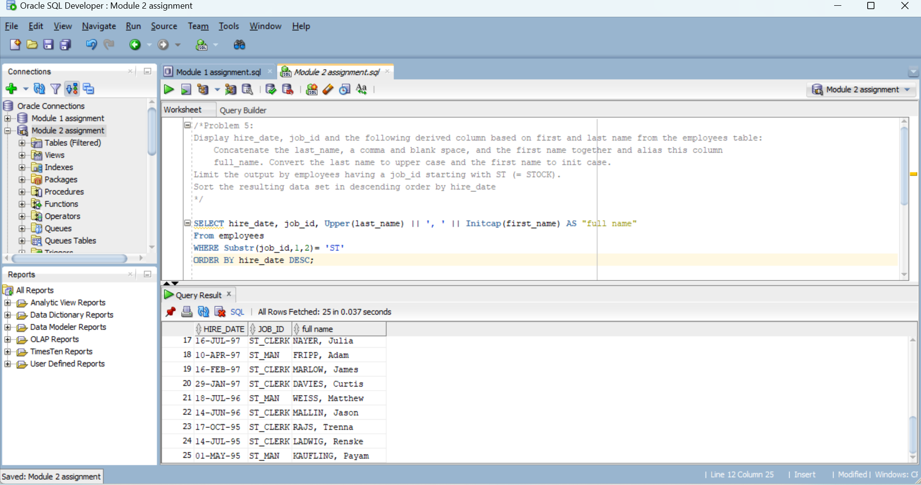

/\***Problem 6**:

Display location_id, city, country_id and the following derived column from the locations table for location_id values less

than 2000:

Display only the beginning street number values from the street_address column and alias this column

street_number. Make sure to remove any leading or trailing blank spaces from the street_number expression.

Order the resulting set by country_id and city.

To format the street_number column use the following formatting command. Issue this command before issue the SQL

statement:

COLUMN street_number FORMAT a20

*/

COLUMN street_number FORMAT a20

SELECT location_id, city, country_id, Trim(Substr(street_address,1, Instr(street_address, ' ',1,1)-1)) AS "street_number"

From locations

WHERE location_id <2000

ORDER BY country_id, city

